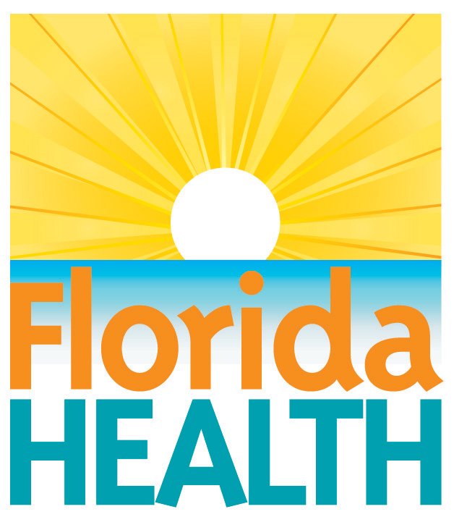
xxx. xx, 2018

doh reminds residents to avoid
contact with stray pets and wildlife
Contact:
Communications Office
NewsMedia@flhealth.gov
(850) 245-4111
Tallahassee, Fla.—After storms and flooding, pets may be displaced. Any loose pet may be lost, frightened, or hurt – and more likely to bite. Even animals that are usually friendly may bite if they are scared or hurt.
To avoid being bitten:
- Do not approach stray pets or wildlife.
- Do not feed or attempt to pet or handle stray pets or wildlife.
- Do not disturb an animal that is sleeping, eating or caring for its young.
- If a strange animal walks toward you, stay calm and slowly move away.
- Bites from dogs are the most commonly reported animal bite. Additional tips for preventing bites from dogs include:
- Dogs are more likely to bite other dogs than people; when walking your own pet dog, avoid areas where free-roaming dogs may be present.
- If another dog attacks your dog, don’t put any part of your body between the dogs; consider carrying a stick or another sturdy object that you can safely use to try to keep the aggressive dog away.
- Do not make eye-to-eye contact with a stray or aggressive acting dog.
- Do not run or scream if a stray dog approaches you – be “still like a tree.” If you fall or are knocked to the ground by a dog, curl into a ball with your hands over your head and neck. Protect your face. Try to stay still and do not scream.
- Report stray dogs to local authorities such as animal control.
If you are bitten by an animal and emergency help is needed, go to a hospital or medical treatment area or call 911.
- Take care of the bite wound:
- Before treating the wound, wash your hands with soap and clean fresh water.
- Remove any item that is in the way of caring for the wound.
- Put pressure on the wound with a clean cloth to stop bleeding.
- After the bleeding has stopped, pour bottled or clean running water over the wound.
- Gently clean around the wound with soap and clean water.
- Pat dry and use an adhesive bandage or dry clean cloth to cover the wound.
- Leave unclean wounds open.
Report the bite to your local animal control agency if they are open. Tell the animal control official everything you know about the animal and where it went.
CDC resources: https://www.cdc.gov/disasters/animalhazards/index.html
For further information, please contact your local county health department or visit www.floridahealth.gov or www.FloridaDisaster.org.
During severe weather and other emergencies, you can count on active alerts from the department's official social media accounts. One of the fastest ways to receive official and accurate health-related information is to monitor @HealthyFla on Twitter and on Facebook.
About the Florida Department of Health
The department, nationally accredited by the Public Health Accreditation Board, works to protect, promote and improve the health of all people in Florida through integrated state, county and community efforts.
Follow us on Facebook, Instagram and Twitter at @HealthyFla. For more information about the Florida Department of Health please visit www.FloridaHealth.gov.

