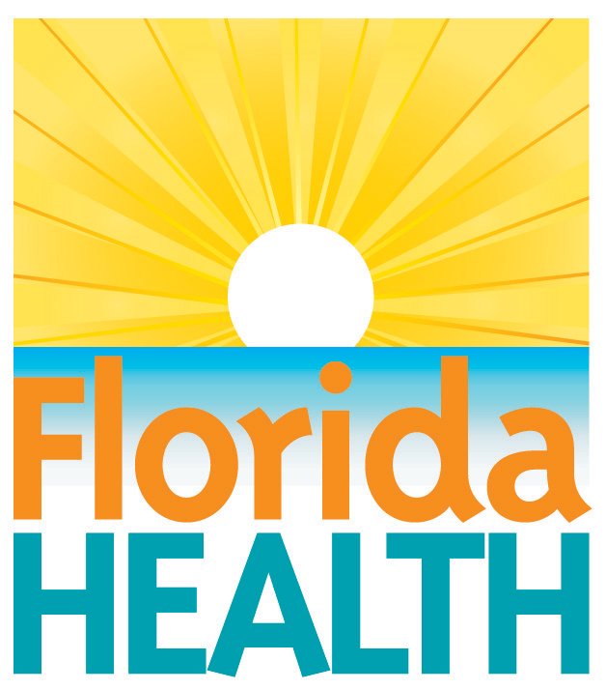
xxx. xx, 2018

DOH Urges Public to avoid carbon monoxide poisonings and exposure
Contact:
Communications Office
NewsMedia@flhealth.gov
(850) 245-4111
Tallahassee, Fla.—As Floridians statewide begin the task of recovering from {storm name}, the Florida Department of Health (DOH) is urging the public to avoid carbon monoxide (CO) exposure by taking precautions with portable generators, gas-powered appliances and charcoal or gas grills. CO is a poisonous gas produced by burning fuels such as gasoline, natural gas, propane, kerosene, charcoal and wood. CO from these sources can build up in enclosed or partially enclosed spaces, such as your home or garage. The risk of illness or death increases with the level of CO in the air and the amount of time exposed.
Depending on the level of exposure, carbon monoxide may cause fatigue, weakness, chest pains for those with heart disease, shortness of breath upon exertion, nausea, vomiting, headaches, confusion, lack of coordination, impaired vision, loss of consciousness, and in severe cases, death.
The department recommends the following precautions to help prevent carbon monoxide poisoning:
- Do not burn charcoal or gas grills inside a house, garage, vehicle, tent or fireplace.
- NEVER use a generator indoors, including in homes, garages, basements, crawl spaces, and other enclosed or partially enclosed areas, even with ventilation. Opening doors and windows or using fans will not prevent CO build-up in the home.
- ALWAYS locate the unit outdoors on a dry surface, away from doors, windows, vents, and air conditioning equipment that could allow CO to come indoors. Follow the instructions that come with your generator.
- Install battery-operated CO alarms or plug-in CO alarms with battery back-up in your home, according to the manufacturer’s installation instructions. The CO alarms should be certified to the requirements of the latest safety standards for CO alarms (UL 2034, IAS 6-96, or CSA 6.19.01).
- Test your CO alarms frequently and replace dead batteries.
- REMEMBER that you cannot see or smell CO and portable generators can produce high levels of CO very quickly.
- If you start to feel sick, dizzy, or weak while using a generator, get to fresh air RIGHT AWAY. DO NOT DELAY.
If you have a poisoning emergency, call your nearest Florida Poison Information Center at 1-800-222-1222. If the victim has collapsed or is not breathing, call 911 immediately.
For further information, please contact your local county health department or visit www.floridahealth.gov or www.FloridaDisaster.org.
During severe weather and other emergencies, you can count on active alerts from the department's official social media accounts. One of the fastest ways to receive official and accurate health-related information is to monitor @HealthyFla on Twitter and on Facebook.
About the Florida Department of Health
The department, nationally accredited by the Public Health Accreditation Board, works to protect, promote and improve the health of all people in Florida through integrated state, county and community efforts.
Follow us on Facebook, Instagram and Twitter at @HealthyFla. For more information about the Florida Department of Health please visit www.FloridaHealth.gov.

