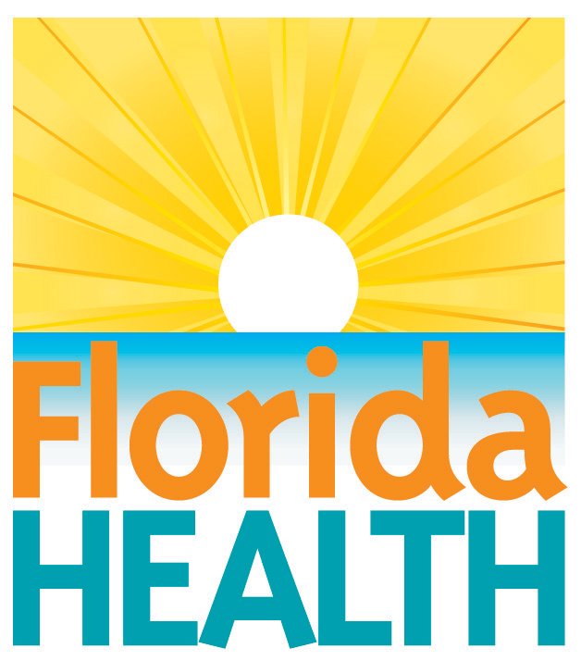
xxx. xx, 2018

doh urges caution with sewage,
septic tanks after Storms/Floods
Contact:
Communications Office
NewsMedia@flhealth.gov
(850) 245-4111
Tallahassee, Fla.—Following the passage of Hurricane {StormName}, residents may be experiencing difficulties with your sewage system not functioning properly. If you have a septic system that operates by a dosing pump, it will not function without electricity. You should refrain from using water in your home until electricity is restored. Without the pump working, the septic tank will fill and may cause backup of sewage in your home.
General precautions:
- Do not let children play in flood waters as these waters may be contaminated by sewage.
- If you live in a low-lying or flood-prone area, the ground in your area may be saturated from heavy rainfalls or flooding from the hurricane. You should use household water as little as possible to prevent backup of sewage into your home
What should I do if sewage backs up into my home?
- If a sewage backup has occurred in your home, stay out of affected areas and keep children away. If your entire home has been saturated, evacuate the home until all affected areas, including but not limited to carpets, rugs, drywall, and baseboards, have been thoroughly cleaned and disinfected.
- If sewage has overflowed in open areas or streets, etc., avoid these areas and especially do not let children play in these areas.
- If you are having problems in areas served by public sewer systems, please contact your utility company to insure they are aware of problems in your area.
How to clean up sewage contaminated items and sewage spills inside your home:
- Wear protective clothing such as rubber boots and waterproof gloves.
- Clean walls, hard-surfaced floors, and other household surfaces with soap and water and disinfect with a solution of 1/4 cup of bleach in one gallon of water. Once cleanup is complete, dry out affected items to prevent the growth of mold.
- Do not mix ammonia cleansers with bleach as toxic vapors will form.
- Wash all linens and clothing in hot water or dry clean them.
- Discard Items that cannot be washed or dry cleaned, such as mattresses, carpeting, wall coverings and upholstered furniture.
For spills outside your home:
- Contact your utility or a registered septic tank contractor for clean up.
- Minor spills requiring immediate attention may be disinfected with regular garden lime from a garden shop. Follow the lime container’s label instructions for personal protective equipment needed. Use lime outdoors only.
  - Sprinkle the lime onto the spill so the spill is dusted mostly white on the surface. If the residue is thicker in some places use a rake to mix the lime and the residue.
  - After a day, rake up the thicker residue and place it in a trash bag for disposal with the other trash. Use a sprinkler or hose to water the lime and residue into the soil.
  - Let the area dry in the sun for a day before allowing access. If there is still white lime dust visible on the yard, water it in until the white dust is gone.
Follow proper hygiene procedures to prevent illness:
- Keep hands and fingers away from the nose, mouth, eyes and ears.
- Wash hands with soap and water immediately after cleanup efforts as well as before eating or drinking.
- Keep fingernails short and clean. Use a stiff brush to remove dirt and foreign materials.
- Do not store fresh work clothes with used work clothes.
- Shower as soon as possible after cleaning up sewage or sewage contaminated flood waters.
For further information, please contact your county health department or visit http://www.floridahealth.gov/environmental-health/index.html or www.FloridaDisaster.org.
About the Florida Department of Health
The department, nationally accredited by the Public Health Accreditation Board, works to protect, promote and improve the health of all people in Florida through integrated state, county and community efforts.
Follow us on Facebook, Instagram and Twitter at @HealthyFla. For more information about the Florida Department of Health please visit www.FloridaHealth.gov.

