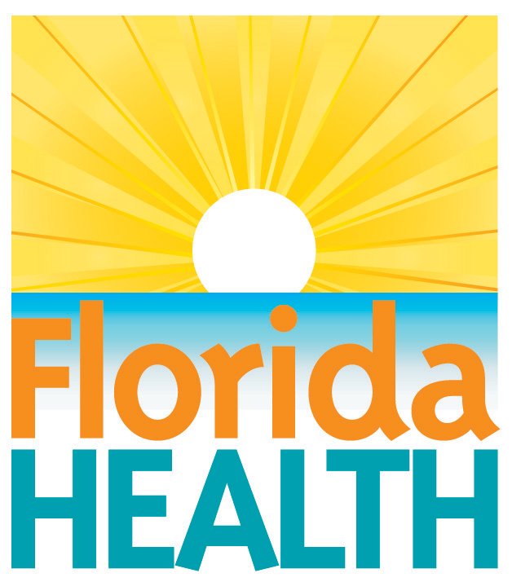
xxx. xx, 2018

DOH Urges residents to not drink
contaminated water
Contact:
Communications Office
NewsMedia@flhealth.gov
(850) 245-4111
Tallahassee, Fla.—As Floridians statewide begin the task of recovering from {Storm Name} and returning to their homes, the Florida Department of Health (DOH) is urging the public to not consume water that is under a boil water notice without boiling it first. If you are under a boil water notice and have no electricity and thus no way to boil water, use bottled water.
Heavy rainfall, especially if accompanied by a tidal surge or flooding, can contaminate your water supply. Consuming water that is contaminated can cause gastrointestinal illness. Individuals cannot assume that a water supply in the storm affected area is safe to drink.
Your local utilities will announce if you are under a boil water notice and when water is safe to drink. Boil water notices are also posted on DOH’s website here.
If you need help locating bottled water, contact local emergency management.
WATER FOR DRINKING AND COOKING:
- Safe sources of drinking water include bottled, disinfected, or both boiled and cooled water. Here are some general rules on using water for drinking and cooking:
- Do not use contaminated water to wash dishes, brush your teeth, wash and prepare food, or make ice. Use only safe drinking water.
- If you use bottled water, know where it came from. Drink only commercially-available bottled, boiled, or disinfected water until your supply is tested and deemed safe. Otherwise, water should be disinfected or both boiled and cooled before use.
- Boiling water kills harmful bacteria and parasites. Bringing water to a rolling boil for 1 minute will kill infectious organisms (germs).
- Water can be disinfected by adding 8 drops of plain unscented household bleach (4 to 6% strength), which is about 1/8 tsp or a dime sized puddle, per gallon of water. If a higher strength bleach is used (8.25% strength), only add 7 drops of bleach. Mix the solution and let it stand for 30 minutes. If the water is cloudy after 30 minutes, repeat the procedure once. Iodine or other disinfection tablets (available at many sporting goods departments and stores) may also be used.
- Containers for water should be rinsed with a bleach solution of one tablespoon of bleach per gallon of water before reusing them. Use water storage tanks and other types of containers with caution. For example, fire truck storage tanks as well as previously used cans or bottles may be contaminated with microbes or chemicals. Do not rely on unverified methods for decontaminating water.
For further information, please contact your local county health department or visit www.floridahealth.gov or www.FloridaDisaster.org.
During severe weather and other emergencies, you can count on active alerts from the department's official social media accounts. One of the fastest ways to receive official and accurate health-related information is to monitor @HealthyFla on Twitter and on Facebook.
About the Florida Department of Health
The department, nationally accredited by the Public Health Accreditation Board, works to protect, promote and improve the health of all people in Florida through integrated state, county and community efforts.
Follow us on Facebook, Instagram and Twitter at @HealthyFla. For more information about the Florida Department of Health please visit www.FloridaHealth.gov.

